CSCI 2467
Lab 7

1. Write a program that contains two overloaded methods that return the average of an array with the following headers:
public static int average(int[] array)
public static double average(double[] array)

Write a program that prompts the user to enter ten integer values into an array named list1, invokes the appropriate method and displays the average value. The program then prompts the user to enter ten double values into an array named list2, invokes the appropriate method and displays the average value.

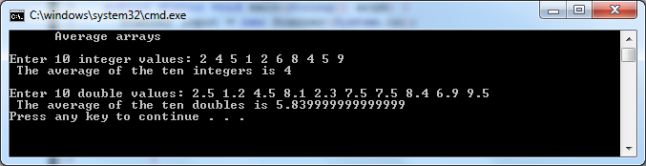

2. Write a method that finds the smallest element in an array of double values using the following header:
public static double min(double[] array)
Write a program that prompts the user to enter ten double values into an array named numbers, invokes the min() method that returns the smallest value, and then dispalys the minimum value.

Do not sort the array inside the method. This is a search.

